Note: This is the message we will use to recruit individuals for the study.

*For survey:*

We are researchers from UC San Diego conducting a research study on evaluating explainable AI (XAI). We are seeking participants that **speak English and are at least 18 years old** to take part in our study. You will be filling out a **survey** [survey link] taking approximately **5 minutes** and you will be compensated **$1.33** ($16 per hour or California minimum wage).

For more information or if you have questions, please contact the research team by email at raman@ucsd.edu.

*For interview:*

We are researchers from UC San Diego conducting a research study on evaluating explainable AI (XAI). We are seeking participants that **speak English and are at least 18 years old** to take part in our study, which involves participating in an **interview** for approximately **30 minutes**. You will be compensated **$8** ($16 per hour or California minimum wage). To schedule a time and date for interview use [this link].

For more information or if you have questions, please contact the research team by email at raman@ucsd.edu.

*Social media post:*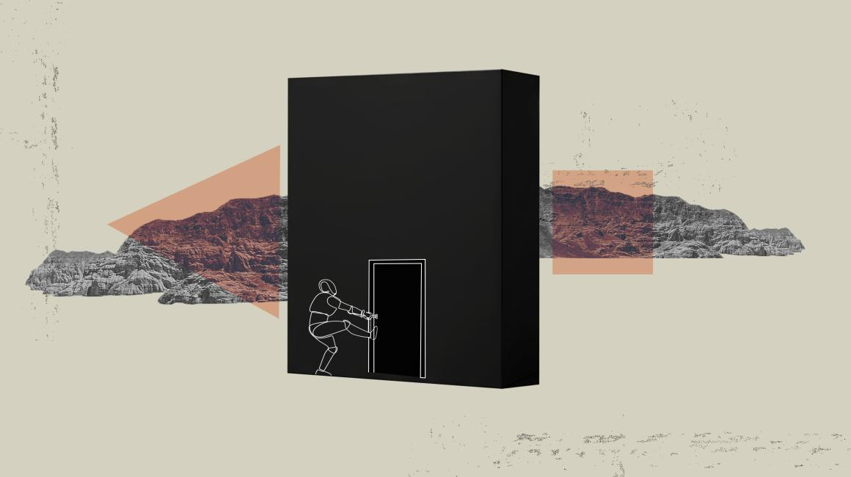

What’s happening in AI models?

How should we explain them?

Help us understand by taking part in our study. Fill out a 5 minute survey or schedule an interview and get paid!

*The following information will be provided in the caption:*

We are researchers from UC San Diego conducting a research study on evaluating explainable AI (XAI). We are seeking participants that **speak English and are at least 18 years old** to take part in our study. You will be filling out a **survey** [survey link] taking approximately **5 minutes** and you will be compensated **$1.33** ($16 per hour or California minimum wage).

You can also schedule an **interview** for approximately **30 minutes**. You will be compensated **$8** ($16 per hour or California minimum wage). To schedule a time and date for interview use [this link].

For more information or if you have questions, please contact the research team by email at raman@ucsd.edu.